Author: Rotimi Dayo.
Module: ACS 133 Physical Systems.
Title: Assignment 2: Dynamic Modelling and App
Development for a Two-Node Thermal System.
Registration Number: 240115322
Date Written: 26th of April 2025.

Contents
INTRODUCTION 3
1. TASK 1: SIMULINK MODEL 4
1.1 System Modelling 4
1.2 Simulink Implementation 5
1.3 Simulation Results 5
2. TASK 2: MATLAB APP DEVELOPMENT 7
2.1 App Overview 7
2.2 App Design & Features 8
2.3 App Functionality 8
2.4 Parameter analysis 9
CONCLUSION 14

INTRODUCTION
This report documents the modelling, simulation, and app development of a two-node thermal system as part of ACS 133 Assignment 2. The task involved two main objectives:
To model the dynamic thermal behaviour of the system using Simulink, based on transfer functions derived from energy balance equations.
To develop an interactive MATLAB App that allows users to modify system parameters, simulate the response, and visualize the effects of different settings on the system’s performance.
The system consists of two thermal capacitances connected through thermal resistances, with heat input at one node and ambient heat exchange. Using transfer function representations, the system's temperature responds to heat input changes which were modelled and simulated.
An App was designed using MATLAB App Designer to enable user interaction with parameters such as resistance, capacitance, heat input magnitude, and step time. The App also displays performance metrics like the steady-state and settling time.
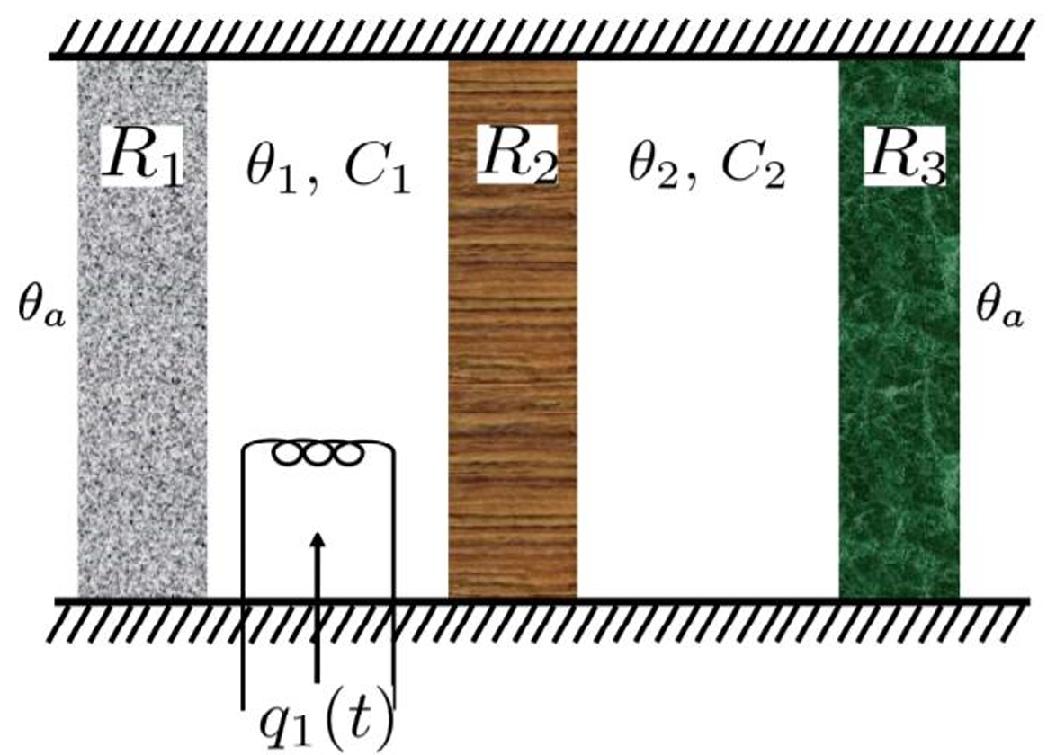
The report covers the approach taken for system modelling, simulation results obtained, App design and functionality, and an analysis of how varying parameters impact the system's thermal response.

This diagram shows the Thermal System.

TASK 1: SIMULINK MODEL

System Modelling
The thermal system consists of two connected nodes, each with thermal capacitance (C₁ and C₂), and connected by thermal resistances (R_{1,} R₂ and R₃). The first node receives a heat input q₁(t), while both ends exchange heat with an ambient temperature θ_{a}.
To model the system dynamically, energy balance equations were written for each node. These equations describe how heat flow, thermal resistance, and capacitance affect the temperature over time.
Using Laplace transforms, the system was converted into the frequency domain and represented using transfer functions:
${\hat{θ}}_{1}\left(s\right)=G_{1}\left(s\right)⋅Q_{1}\left(s\right)$, ${\hat{θ}}_{2}\left(s\right)=G_{2}\left(s\right)⋅Q_{1}\left(s\right)$
$$G_{2}\left(s\right)=\frac{\frac{1}{C_{1}C_{2}R_{2}}}{s^{2}+s\left(\frac{1}{C_{1}R_{12}}+\frac{1}{C_{2}R_{23}}\right)+\frac{R_{2}^{2}-R_{12}R_{23}}{C_{1}C_{2}R_{12}R_{23}R_{2}^{2}}}$$
$$G_{1}\left(s\right)=\frac{\frac{1}{C_{1}}s^{2}+s\left(\frac{1}{{C^{2}}_{1}R_{12}}+\frac{1}{C_{1}C_{2}R_{23}}\right)+\frac{1}{C_{1}^{2}C_{2}R_{12}R_{23}}}{s^{3}+s^{2}\left(\frac{2}{C_{1}R_{12}}+\frac{1}{C_{2}R_{23}}\right)+s\left(\frac{1}{C_{1}^{2}R_{12}^{2}}+\frac{1}{C_{1}C_{2}R_{12}R_{23}}+\frac{R_{2}^{2}-R_{12}R_{23}}{C_{1}C_{2}R_{12}R_{23}R_{2}^{2}}\right)+\frac{R_{2}^{2}-R_{12}R_{23}}{C_{1}^{2}C_{2}R_{12}^{2}R_{23}R_{2}^{2}}}$$

Where ${\hat{θ}}_{1}\left(s\right)$ and ${\hat{θ}}_{2}\left(s\right)$ are the Laplace transforms of the temperature changes (relative to ambient temperature) and $Q_{1}\left(s\right)$ is the Laplace transform of the heat input.
The full expression of $G_{1}\left(s\right)$ and $G_{2}\left(s\right)$ were provided in the assignment. These transfer functions were used in the Simulink model to compute the time-domain responses of ${\hat{θ}}_{1}\left(t\right)$ and ${\hat{θ}}_{2}\left(t\right)$.

Simulink Implementation
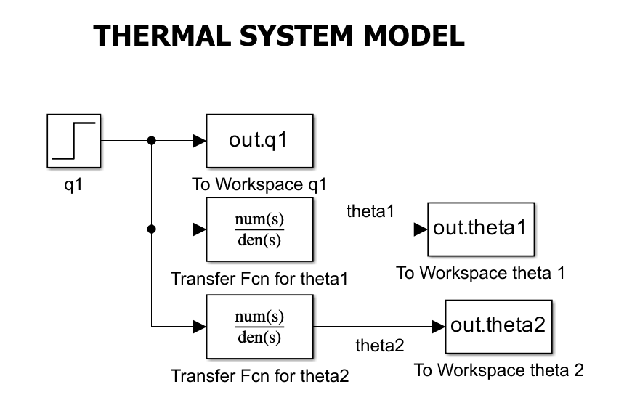
Figure 1.1: The Simulink model of the thermal system.
The thermal system was implemented in Simulink using a transfer function-based approach. This was modelled using:
- Step block: to model the heat input q₁(t) which applied a user – defined heat amplitude after a specified time delay. The inputs for this block were two variables qamp (the step amplitude) and qtime (the step time in minutes).
- Transfer Function block: the step block was fed as input to the transfer function blocks each representing the Laplace – domain behaviour of ${\hat{θ}}_{1}\left(s\right)$ and ${\hat{θ}}_{2}\left(s\right)$. The transfer functions coefficients were calculated in MATLAB workspace using the given thermal resistance, capacitance and derived values of R₁₂ and R₁₃. Where $R_{12}=\frac{R_{1}×R_{2}}{R_{1}+R_{2}}$ and $R_{13}=\frac{R_{1}×R_{3}}{R_{1}+R_{3}}$ . The numerator and denominator for each transfer functions block were passed directly into each block.
- To Workspace block: To capture the simulation output, the To Workspace blocks were used for each signal: theta1 (${\hat{θ}}_{1}\left(t\right)$), theta2 (${\hat{θ}}_{2}\left(t\right)$) and q₁(t). All these were saved as structures with time format to allow for easy plotting in MATLAB.

Simulation Results
The system was simulated for 7200 seconds (120 minutes) to observe the temperature response of both nodes under a step heat input of 3 Watts applied at 600 seconds (10 minutes). The graph of the temperature response against time and the heat input against time was plotted and the stepinfo() function was used to calculate the steady state and the Settling time to 2% but to get the actual settling time I tuned the code to adjust the settling time based on the step time (qtime) and not when the simulation starts
Figure 1.2 shows the temperature responses $θ_{1}\left(t\right)$ and $θ_{2}\left(t\right)$. As expected, both responses start at 293.15K which is the ambient temperature but $θ_{1}$ rises more quickly and reaches a higher steady state value, as it is directly connected to the heat source. $θ_{2}$ responds more slowly due to thermal resistance between the two nodes.
The steady-state and settling time values were:
- Theta1 Steady-State: 313.15 K, Settling Time: 32.52 minutes.
- Theta2 Steady-State: 303.15 K, Settling Time: 39.72 minutes.

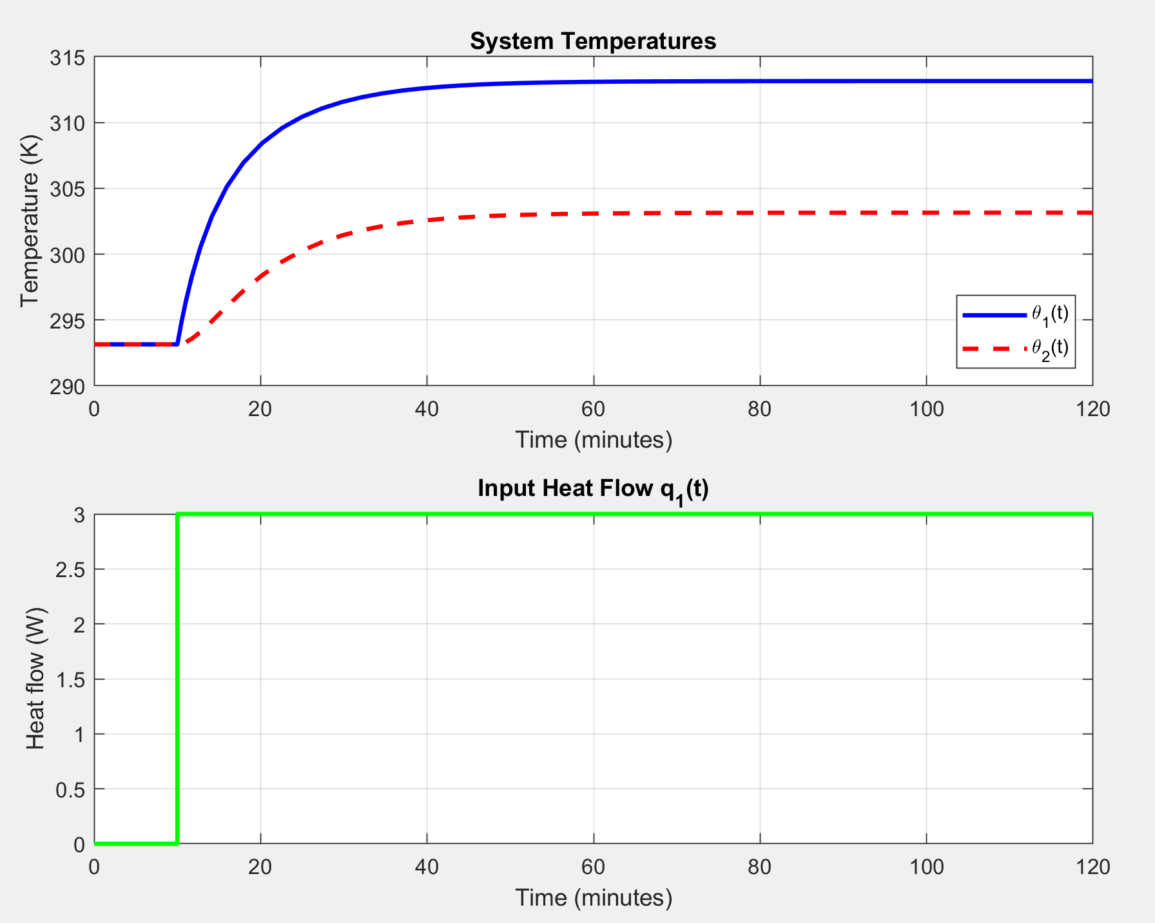
Figure 1.2: Graph of the temperature responses and the Heat flow.
Although the transfer function for θ1​ is third-order and for θ2​ is second-order, the system responses observed in simulation resemble first-order behaviour. This is due to the strong thermal damping due to the resistances and high thermal inertia from the large capacitances within the system, which smooth out higher-order effects and prevent oscillations. As a result, both nodes rise gradually to their steady-state values without overshoot, characteristic of heavily overdamped, first-order-like systems.

TASK 2: MATLAB APP DEVELOPMENT

App Overview
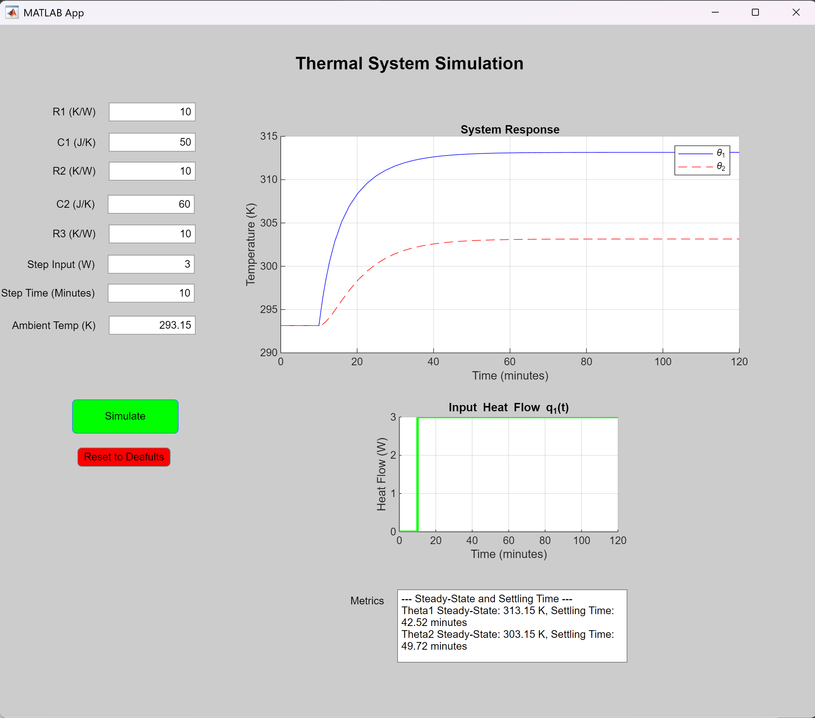
Figure 2.1: The App’s Graphical User Interface.
The MATLAB App was developed using App Designer to allow interactive simulation and analysis of the two-node thermal system modelled in Task 1. The App allows users to adjust key system parameters such as thermal resistances, capacitances, ambient temperature, and heat input characteristics.
The App provides a graphical user interface for running simulations, visualizing temperature and heat flow responses, and observing the impact of different parameters on system dynamics. In addition, the App displays performance metrics such as the steady state and settling time for both thermal nodes.

App Design & Features
The user interface consists of multiple numeric input fields for parameters:
- Thermal Resistances: R_{1,} R₂ and R₃
- Thermal Capacitances: C₁ and C₂
- Ambient Temperature: theta_a
- Step heat input: amplitude and time
The user interface also consists of a “Simulate” button which runs the Simulink model with the current inputs, and a “Reset to Defaults” button which resets all fields to their original values.
The App also includes two plots:
- A graph showing $θ_{1}\left(t\right)$ and $θ_{2}\left(t\right)$
- A separate plot for the heat input q₁(t)
Below the graphs, the App also displays the Steady state and Settling time to 2% for each temperature signal after every simulation run.

App Functionality
When the Simulate button is pressed, the App collects all user-defined inputs from the numeric fields, including thermal parameters and step input settings. These values are then used to calculate the transfer function coefficients for the system using standard formulas derived in Task 1.
The App passes all relevant variables (such as R_{1,} R₂, R_{3,} C_{1,} C₂, theta_a, qamp and qtime) to the Simulink model using the assignin(‘base’, …) function, allowing the model to update dynamically.
The Simulink model is then simulated using the sim() function, and the outputs for each signal are returned as structures with time. The App extracts these signals and plots them on the two UI axes.
In addition, the App uses the stepinfo() function to automatically compute and display performance metrics such as the Steady state and Settling time for both temperature responses.
When the Reset to Defaults button is pressed, the App resets all the variables to the values used in Task 1 by using the assignin(‘base’, …) function, allowing the user to be able to reset the system to default values.
Figure 2.2 shows that Error handling was implemented within the App. Before running a simulation, the App checks that all input values are numeric, non-empty and finite. If any invalid inputs are detected, the App displays an error message using uialert() dialog box.
A specific check was also added to prevent the user from entering a resistance value of zero, as this would result in division by zero errors in the transfer function calculation. This input validation alerts the user if an input is not allowed.
% Validate numeric inputs
if any(isnan([R1, R2, R3, C1, C2, theta_a, qamp, qtime])) || ...
any(isinf([R1, R2, R3, C1, C2, theta_a, qamp, qtime]))
uialert(app.UIFigure, ...
'Please make sure all values are numeric and not empty.', ...
'Invalid Input');
return;
end
% Check for zero resistance (physically invalid)
if R1 == 0 || R2 == 0 || R3 == 0
uialert(app.UIFigure, 'Resistance values cannot be zero.', 'Invalid Input');
return;
end
Figure 2.2: Code snippet showing input validation in the App

Parameter analysis
To understand how different parameters influence the thermal system’s behaviour, a series of simulations were run using the App. For each test case the default values were used for every other parameter but the one that is being tested. All test scenarios are compared to the system at default case.
- Test Case 1: Increasing R₁ from 10 to 50 K/W
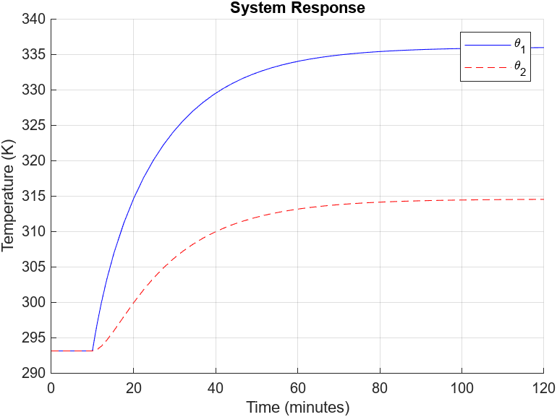
Figure 2.3: Increasing R₁ .
Increasing R₁ effectively insulates the first capacitance from its surroundings, causing more heat to accumulate in capacitance 1, raising its temperature. This also slightly impacts capacitance 2 due to higher $θ_{1}$ but delays its stabilization.
$θ_{1}$ rises faster and reaches a higher steady state temperature of 335.95K and takes longer to settle at 63.32 minutes . This occurs since less heat is lost to the environment.
$θ_{2}$ also experiences an increase( Steady state: 314.54 & Settling time: 68.72 ) due to the high temperature of $θ_{1}$ but has a slower rise due to reduced heat flow out of capacitance 1.
- Test Case 2: Increasing R₂ from 10 to 50 K/W
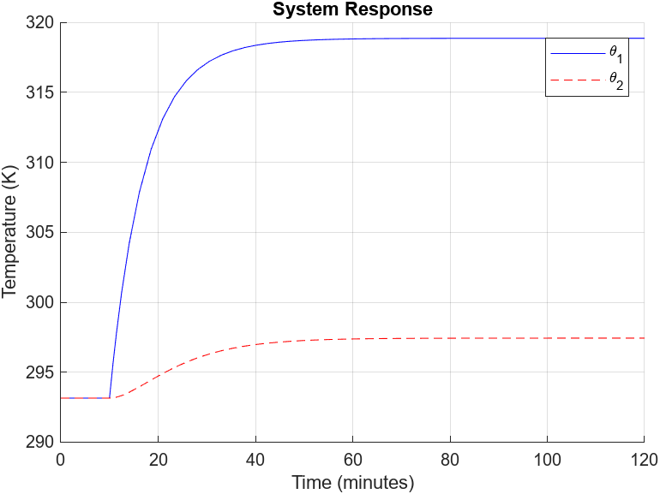
Figure 2.4: Increasing R₂.
Increasing R₂ creates a bottleneck between the two nodes. Since less heat can flow from capacitance 1 to capacitance 2, θ₁ absorbs most of the input heat and climbs faster and higher. θ₂, on the other hand, responds sluggishly, with a clear delay in reaching steady state.
This simulates a poorly conducting connection like having thermal lag between parts of a system.
$θ_{1}$ rises quickly to a higher steady state value of 318.86K and settles quickly at about 29.89 minutes.
$θ_{2}$ rises much more slowly and settles at a lower temperature of 297.44K and settles at 46.63 minutes. There is a clear delay, and this is due to near thermal isolation.
- Test Case 3: Increasing R₃ from 10 to 50 K/W
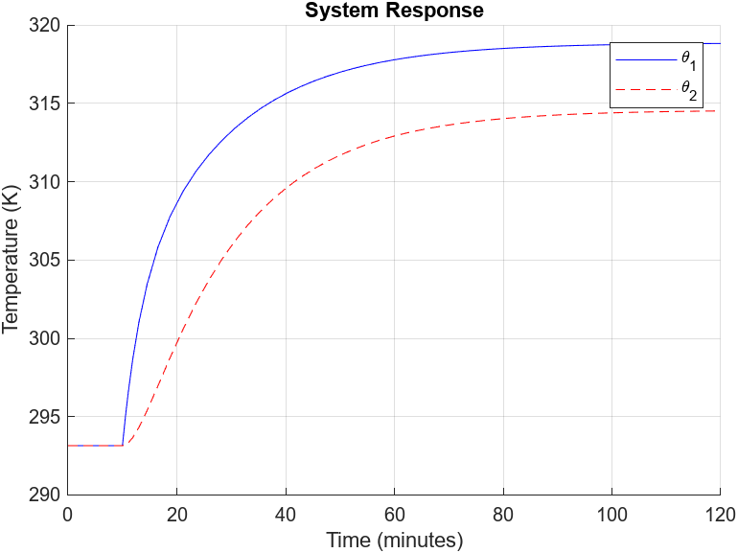
Figure 2.5: Increasing R₃.
Increasing R₃ makes the 2nd Capacitance or node 2 lose heat to the environment more slowly, acting as better insulation. This allows $θ_{2}$ to hold onto heat longer and reach a higher final temperature.
Because node 1 doesn’t connect directly to R₃, $θ_{1}$only experiences a slight increase in Steady state value due to a slightly higher $θ_{2}$.
$θ_{1}$(t) is nearly identical but it has a higher steady state value of 318.82K and settling of 62.17 minutes.
$θ_{2}$ has a much higher steady state value of 314.52K and settling time of 72.29 minutes.
- Test Case 4: Increasing C₁ from 50 to 100 J/K
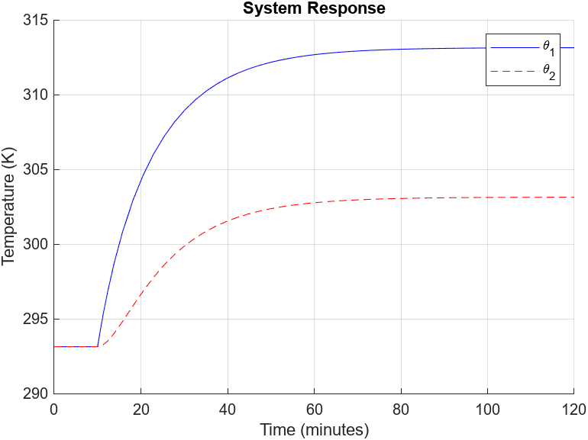
Figure 2.6: Increasing C₁.
Increasing C₁​ increases the thermal mass at node 1, meaning it takes more energy to raise its temperature. As a result, $θ_{1}$ responds more sluggishly, showing a longer rise time and settling time.
Since $θ_{2}$ depends on the heat flow from $θ_{1}$, it also heats up more slowly, though the effects is less dramatic. This simulates a larger or denser object at node 1 that holds more thermal energy.

$θ_{1}$(t) rises much slower but reaches almost the exact same steady state of 313.14K, but a much higher settling time of 52.14 minutes.

$θ_{2}$(t) rises slightly slower due to the delayed $θ_{1}$ input but also reaches the exact same steady state of 303.15K and a much higher settling time of 58.23 minutes.

- Test Case 5: Increasing C₂ from 60 to 120 J/K
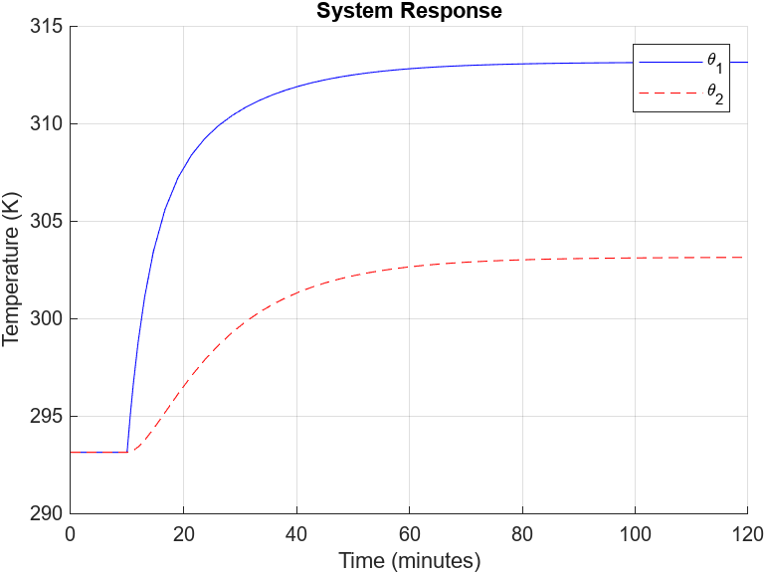
Figure 2.7: Increasing C₂.
Doubling C₂​ increases the thermal inertia of node 2 meaning it takes longer to absorb heat and raise its temperature. This results in a delayed and smoothed response in θ₂, with a much longer settling time.
$θ_{1}$(t) is barely affected with the same steady state of 313.14K but a higher settling time of 47.30 minutes.
$θ_{2}$(t) has a much slower rise and higher settling time of 43.14 minutes but the same steady state of 303.14K.

- Test Case 6: Increasing the Step Amplitude from 3 to 10 W
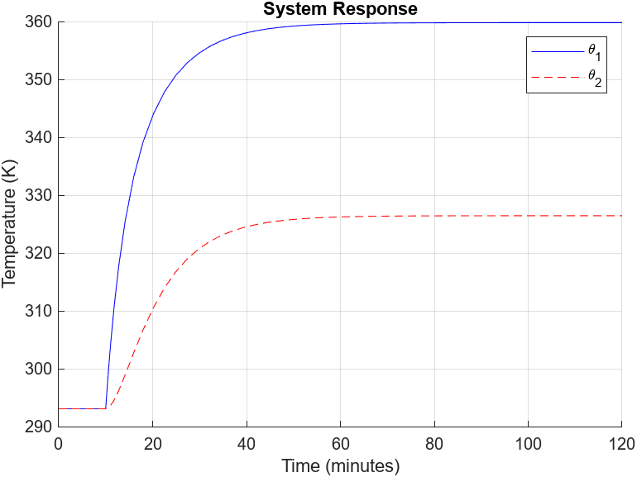
Figure 2.8: Increasing the Step Amplitude
A larger heat input delivers energy to the system at a much higher rate. Both thermal nodes absorb this energy and heat up more rapidly. While the time it takes to stabilize did not change, the system reaches much higher absolute temperatures.
This test shows how the magnitude of the input affects the scale of the response, but the system’s underlying shape and lag remain governed by R and C values.
$θ_{1}$(t) rises rapidly and reaches a much higher steady state of 359.82K and settles at the same time of 32.52 minutes.
$θ_{2}$(t) also shows a significantly higher steady state value of 326.48K and settles at the same time of 39.72 minutes. It rises faster but still lags behind $θ_{1}$ due to thermal resistance and capacitance.
- Test Case 7: Increasing the Step Time from 10 to 30 minutes
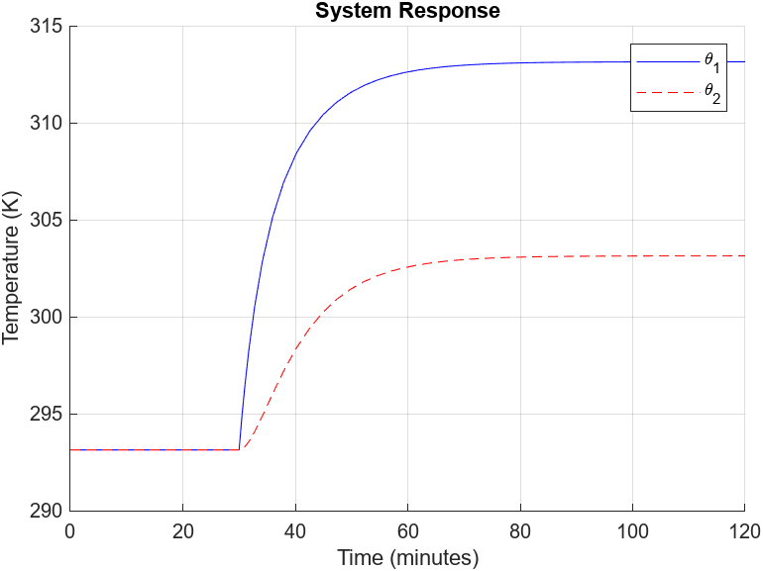
Figure 2.9: Increasing the Step Time.
Increasing the step time delays the application of heat to the system. The system remains at ambient temperature until the input is triggered, after which the temperature responses behave exactly as before. This test demonstrates timing control, not dynamic changes.
- Test Case 8: Decreasing the Ambient Temperature from 293.15 to 280 K
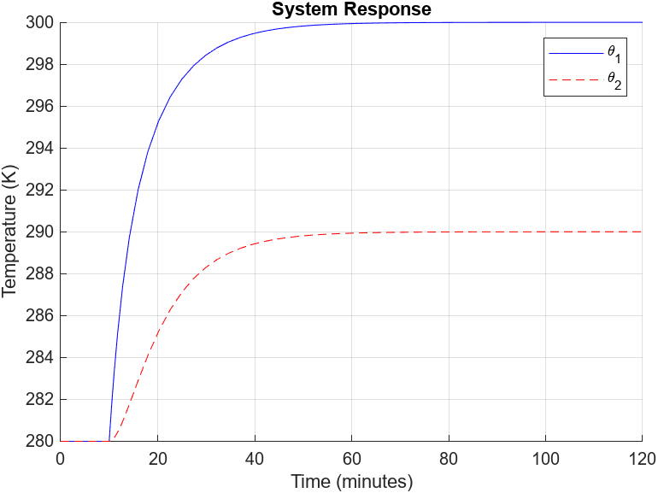
Figure 2.10: Decreasing the Ambient Temperature.
Lowering $θ_{a}$ ​ creates a colder environment for the thermal system. Since the model calculates temperature relative to ambient, the internal dynamics don’t change — but the actual temperatures of both nodes are lower throughout the simulation.
Both $θ_{1}$(t) and $θ_{2}$(t) are unchanged but have a lower steady state temperature of 300.00K and 290.00K.
The opposite will occur if the ambient temperature was increased instead.

CONCLUSION
In this project, I was able to model a two-node thermal system, simulate it in Simulink, and build an interactive App using MATLAB App Designer. The Simulink model showed how the system temperatures respond to a step heat input, while the App allowed for easy changes to parameters like resistances, capacitances, heat input values and ambient temperature.
By testing different settings, I could clearly see how parameters affect things like how fast the system heats up or how long it takes to settle.
Overall, this assignment helped me better understand system modelling, dynamic response analysis, and how to connect MATLAB and Simulink together in a real application.

